Product
Elastomeric membrane obtained by mixing EPDM (Ethylene Propylene Diene Monomer) with oils and fillers, followed by calendering and vulcanization.

Application examples
- to avoid ascendant moisture
- as a weir at the sole of cavity walls
- as a weir beneath thresholds
- around curtain walls
- for steel facades
- for the renovation of roof gutters
- for outside facade insulation

Colour
Black

Thickness
0,60 mm (-5%/+10%)

Widths
100-110-120-130-140-150-160-170-180-190-200-210-220-
230-240-250-260-270-280-290-300-… - 1.300 mm

Lengths
20 or 25 meter
The length may vary by ±5% due to the elasticity of the material.

Execution
- In strips
- with 1, 2 or without adhesive layers

Properties
- Excellent resistance to weather conditions, UV- radiation and ageing.
- Excellent long-term waterproofing
- Ready to apply on profile
- Very elastic
- Lightweight and recyclable
- Excellent thermal insulation
- Solvent-free

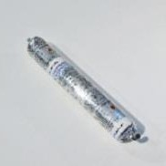
Building bonding paste NOVOPROOF® FA A one-component special adhesive and sealant based on synthetic rubber, which cures to a durable elastic rubber. Colour: black. Especially developed for bonding and sealing the NOVOPROOF® FA EPDM on the most common building materials such as aluminum (untreated,
anodized, powder-coated), mineral surfaces (concrete, stone, brick, plaster), steel (galvanized, powder-coated), wood (test before application), overlaps between EPDM panels.
Aluminium Sausages of 600 ml (12).

NOVOPROOF® FA EPDM 0,60 MM
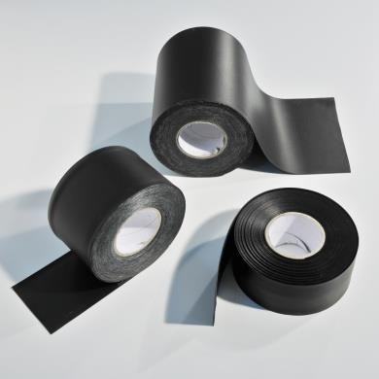
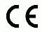

Technical properties membrane

Property | Value + unit
Density | 0,75 Kg/m²
Hardness shore A | 65° +/- 5
Temperature resistance | -30°C to +116°C
Elongation at break  (EN 12311-1) | ≥ 400 %
Tensile strength  (EN 12311-1) | ≥ 210 N/50 mm
Tear resistance  (EN 12310-1) | ≥ 80 N
Reaction to fire  (EN ISO 11925-2/EN 13501-1) | E
Resistance to air passage | ≤ 0,1 m³/(m²/h/50 Pa)
Resistance to vapour  diffusion (µ) | 60.000 +/- 18.000
Certificates | ATG 12/2891

Tip
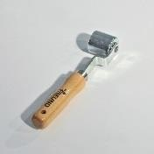
We recommend the use of a hard roller to press the EPDM membrane firmly on the surface. Two types are available: one of hard silicone rubber and one of steel

Accessories
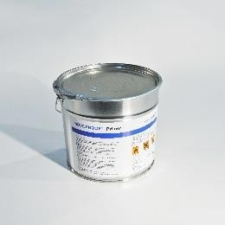
NOVOPROOF® Primer
Adhesion promoter for the use of the contact adhesive Kleber TA or the building bonding paste NOVOPROOF FA on porous, moist surfaces or when using them at temperatures between
+ 3 °C and -10°C.

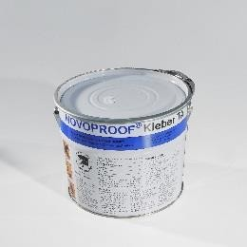
NOVOPROOF® Kleber TA
Contact adhesive based on synthetic rubber used for bonding the membrane on various substrates (wood, aluminum and stone).

NOVOPROOF® FA EPDM 0,60 MM

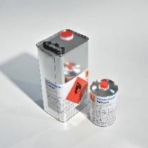
NOVOPROOF® Cleaner
Property | Kleber TA | Kit FA | Primer
Colour | black | black | black
Density | 0,85 Kg/l | 1,15 Kg/l | 0,835 Kg/l
Solids | 43,30 % | 79 % | 36,30 %
Flashpoint | -15°C | -8°C | -18°C
Viscosity | 400 mPa.s  +/- 100 | 4500 mPa.s  +/- 1000 | 900 mPa.s
Packing | 0,8 & 4,7 Kg | 600 ml  12 per doos | 4,50 Kg
Storage | 12 months | 12 months | 12 months

Used for cleaning the EPDM FA (if not clean enough) before gluing it with the building bonding paste FA or with the contact Kleber TA.

Other products

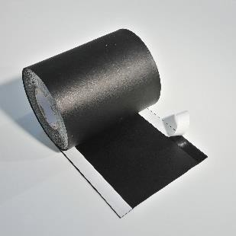
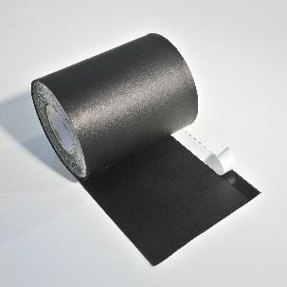
EPDM with 1 of 2 butyl adhesives

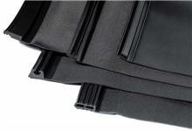
EPDM provided with an extruded EPDM-profile according window frame
Examples profiles (in cross-section)
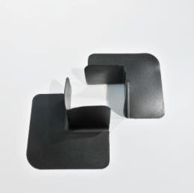
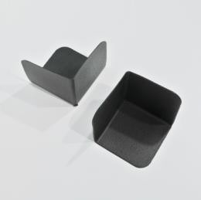
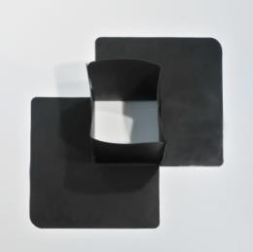
Preformed inside and outside EPDM corners
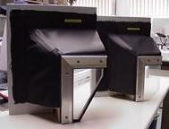

EPDM customized according window dimension
Note
The details and information given in this literature are based on best current knowledge. They are intended to serve as general information only and it is advised that the user conducts their own tests for their specific set of conditions to determine the suitability of the product for its proposed use. No warranty or liability is given or implied regarding any part of these instructions or details, or the completeness of the information. We reserve the right to modify, or change, the specifications and information without advance notification. All goods are supplied subject to our standard conditions of sales, copies of which are available upon request.
Technical data of supplier: 05 2014
The producer reserves the right to make changes. 2015 09 15

