QT905
EXTERIOR WATERPROOF MASKING TAPE

TECHNICAL DATA
Contact your BDT sales representative for other available sizes. 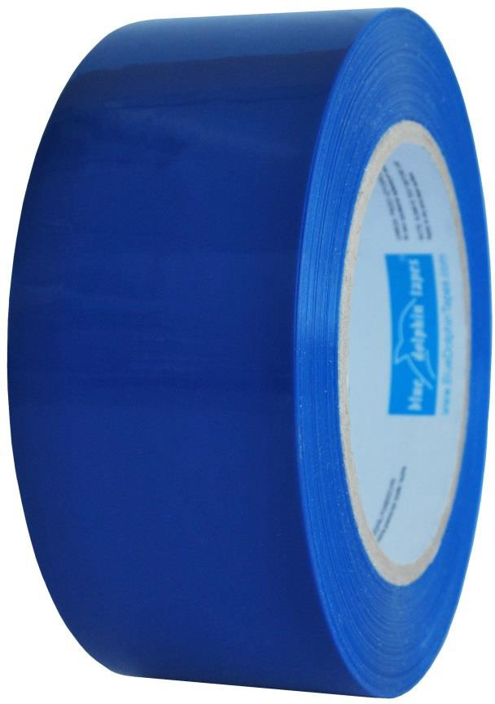
ADVANTAGES AND BENEFITS
> Smooth surfaces
> Vinyl, glass, plastic, aluminum
> Clean & easy removal
> UV resistant

TYPICAL APPLICATIONS
> Painted walls & trims
> Lacquered / Varnished woodwork
> Glass, plastic , metal

CONSTRUCTION
Overall Grade: Outside grade
Backing: LDPE
Adhesive: Rubber based, transparent adhesive
COLOR(S)
Blue | Orange

STANDARD SIZE
Width(s): 48mm / 2"
Length(s): 50m / 60yd

PHYSICAL PROPERTIES

 | STANDARD VALUES | UNITS | TOLERANCE
Thickness | 115 | my | (+/- 10%)
Adhesion to Stainless Steel 180º | ≥ 9 | N/2,5cm | -
Tensile Strength | N / A | ­ | -
Elongation | N / A | ­ | -
Service Temperature Range | from -10 to +60 | º C | -
 | from 14 to 140 | F | -

The following properties are typical and should not be considered specifications. All properties are approximate and are based on tests believed to be reliable and preformed conformance with recommended test methods. These values are presented for comparison purposes and do not represent a guarantee by the manufacturer. The user should determine whether the product is fit for a particular purpose and is suitable for the user's method of application before use.

STORAGE & USAGE CONDITIONS

Tape should be stored in its original packaging in a cool, dry area (not more than 21°C (70°F) and 50% relative humidity) away from direct sunlight and should be used within 12 months of date of shipment. Surfaces to which tape is applied should be clean, dry and free of grease, oil or other contaminants.

